Freebsd installation guide for Virtualbox

Use spacebar to select and Enter to go forward.

<https://docs.freebsd.org/en/books/handbook/>

Sources

<https://youtu.be/1VpVvsVbT-g>

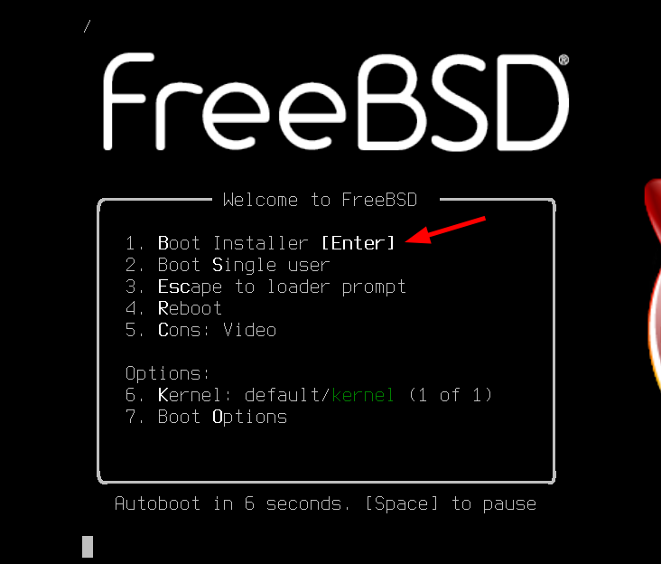

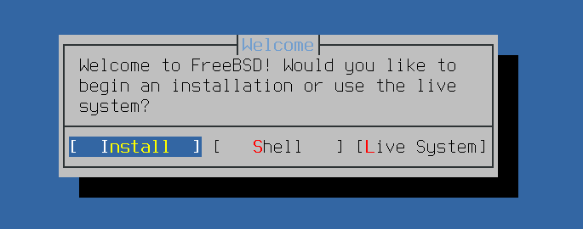

Choose keyboard and go on with enter

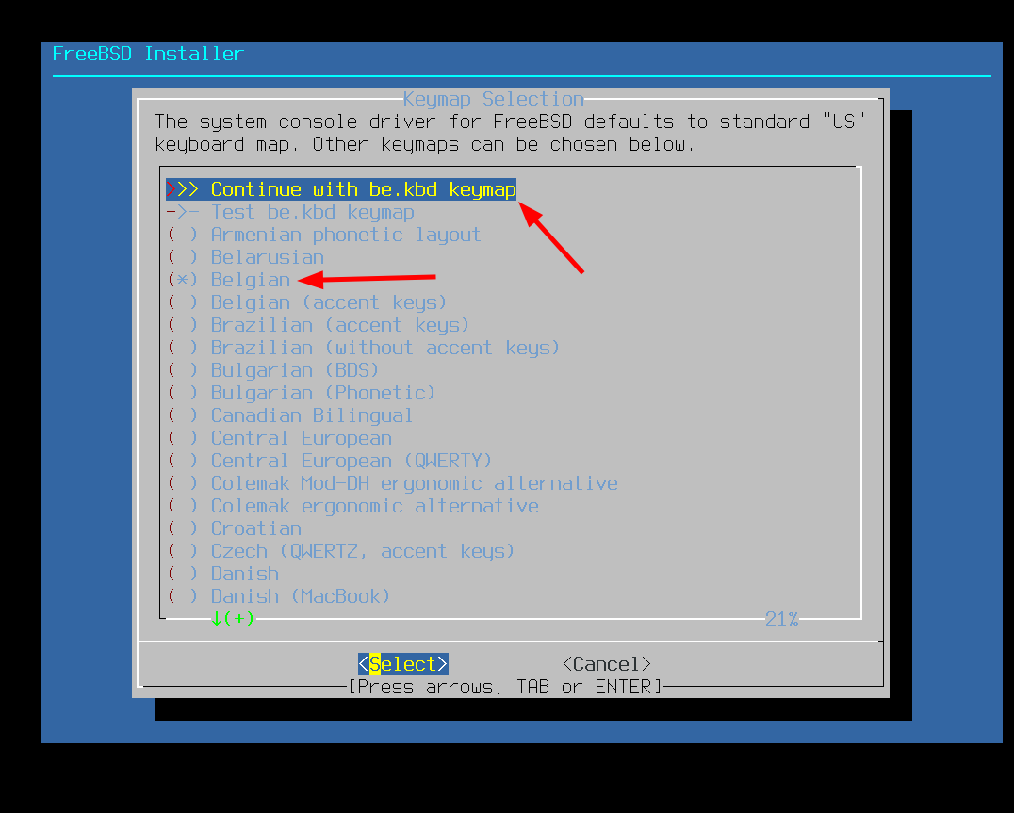

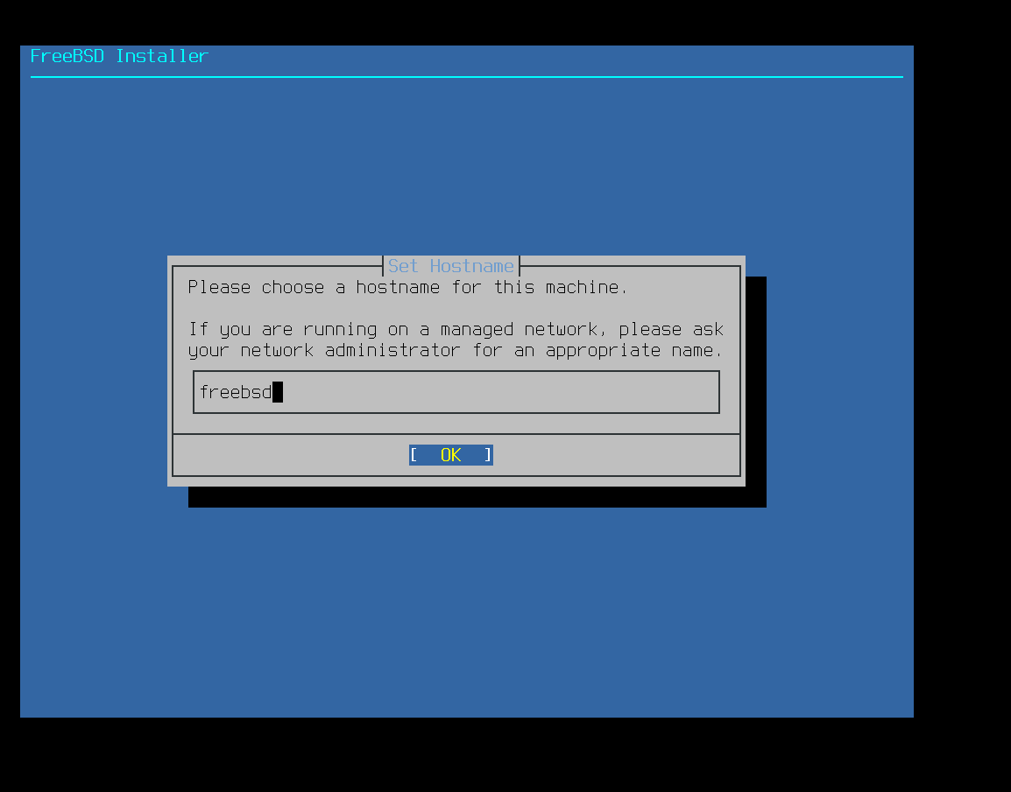

Choose optional components

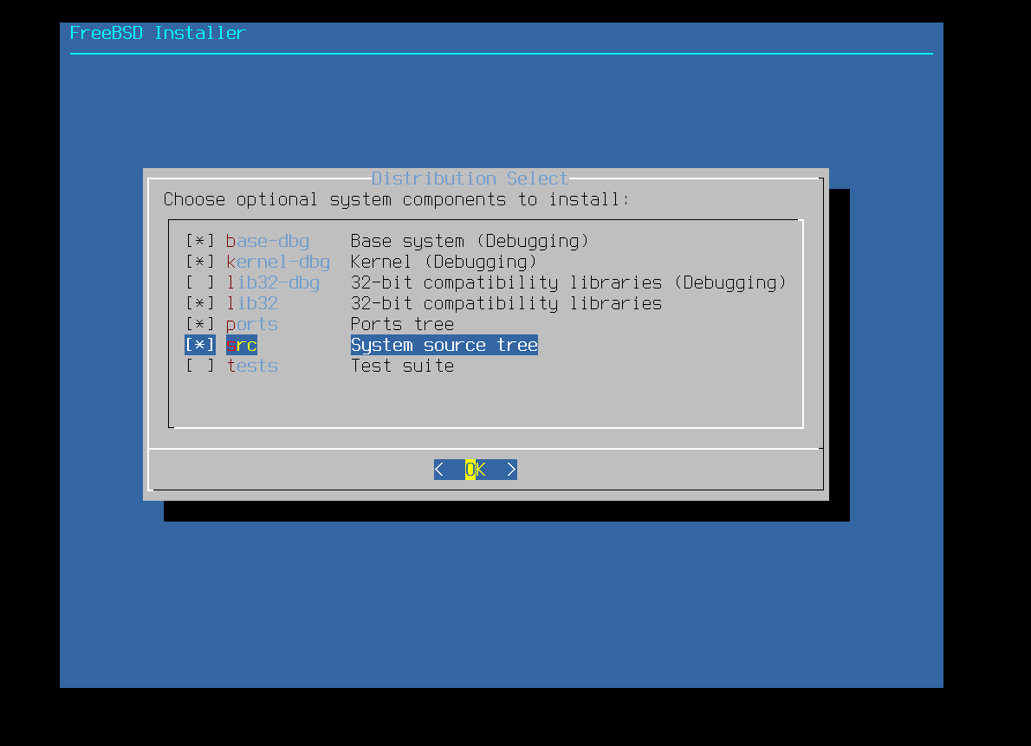

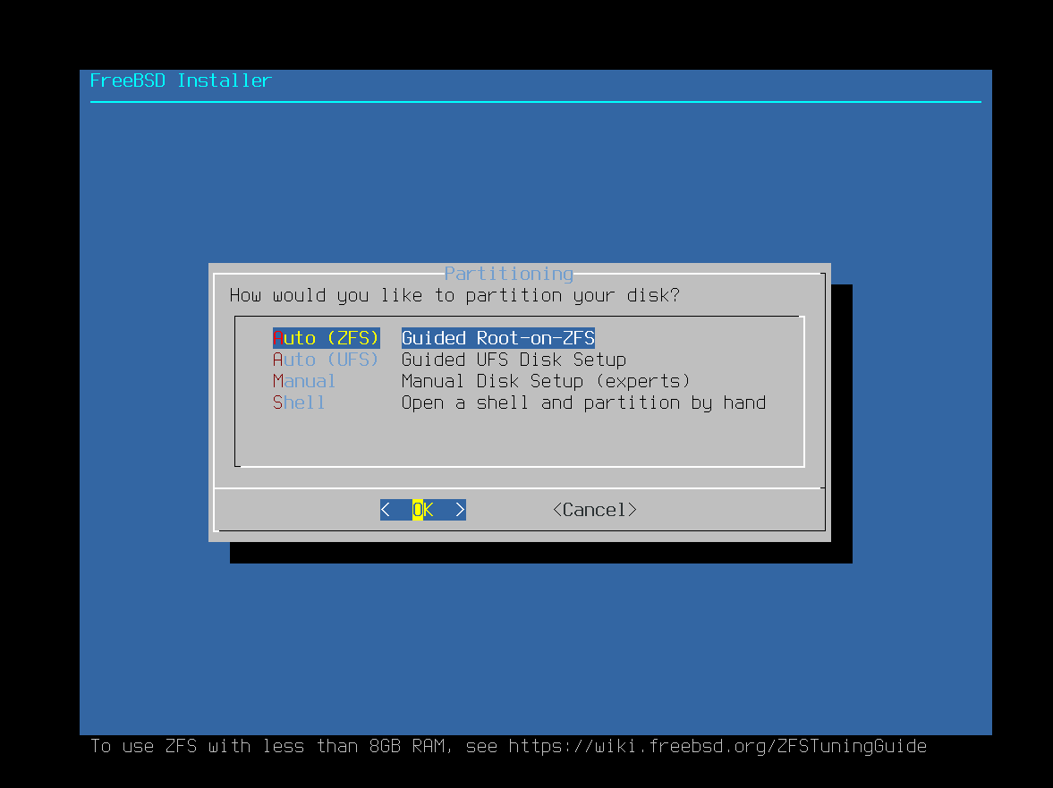

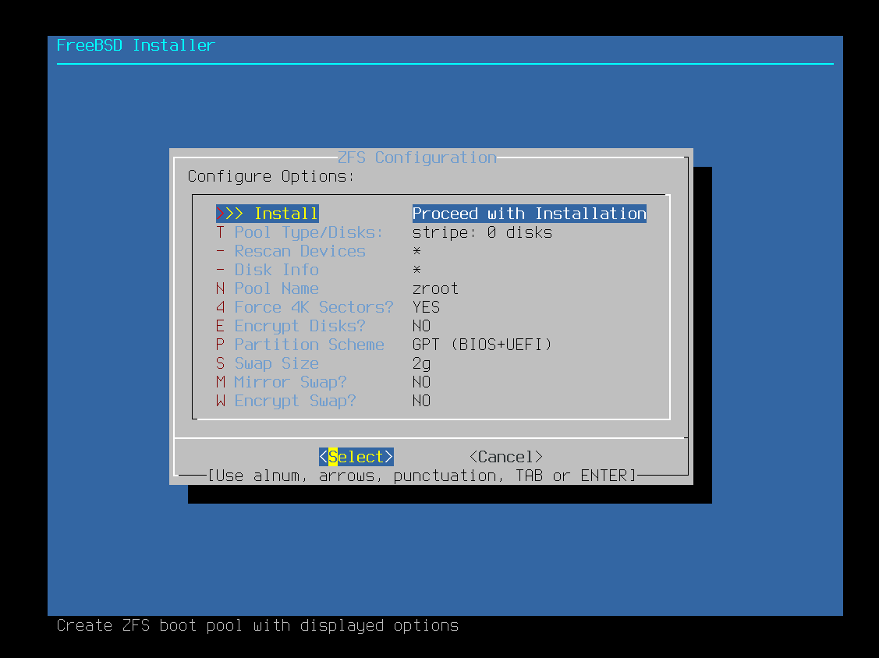

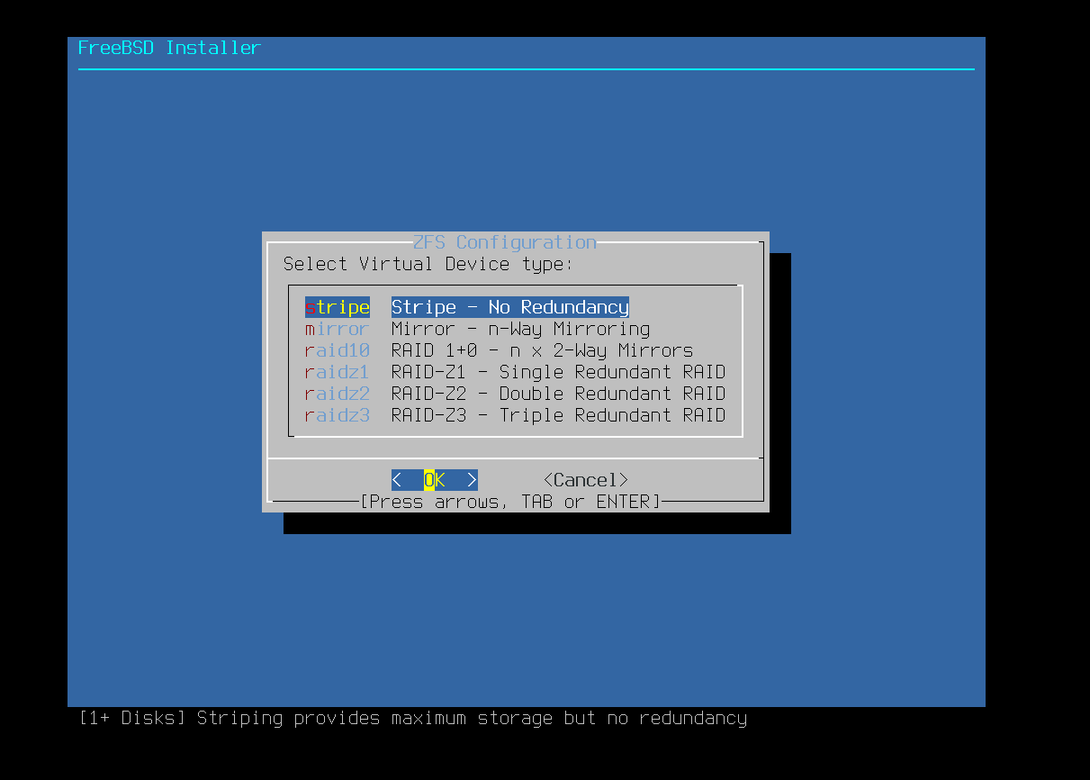

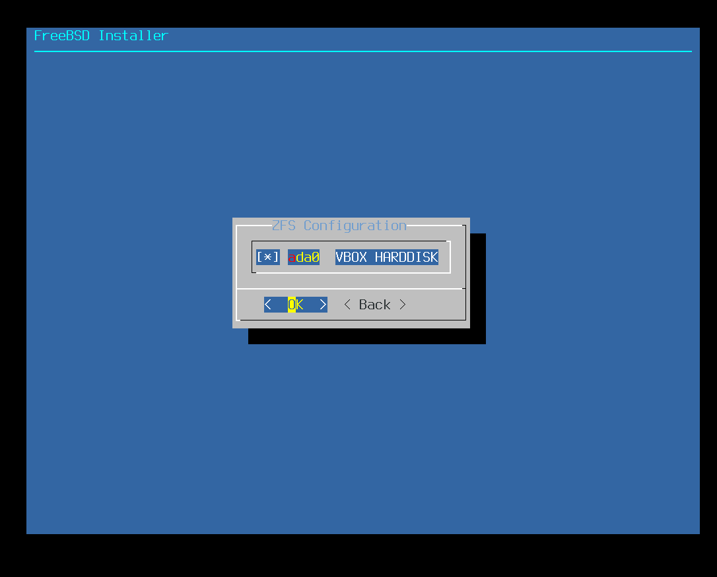

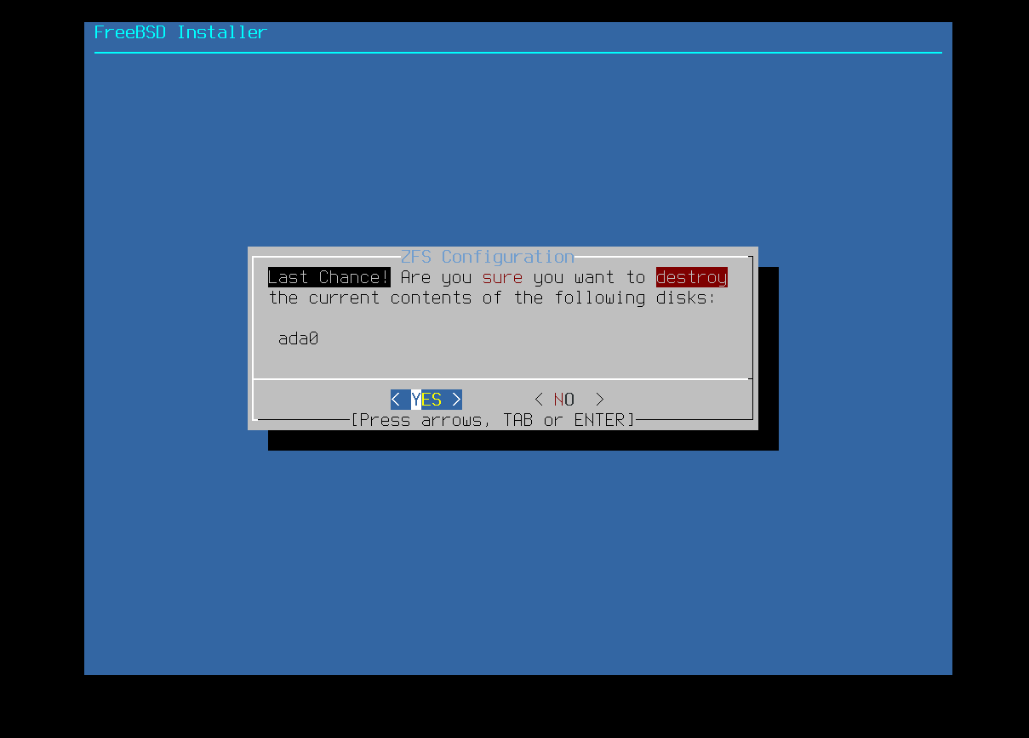

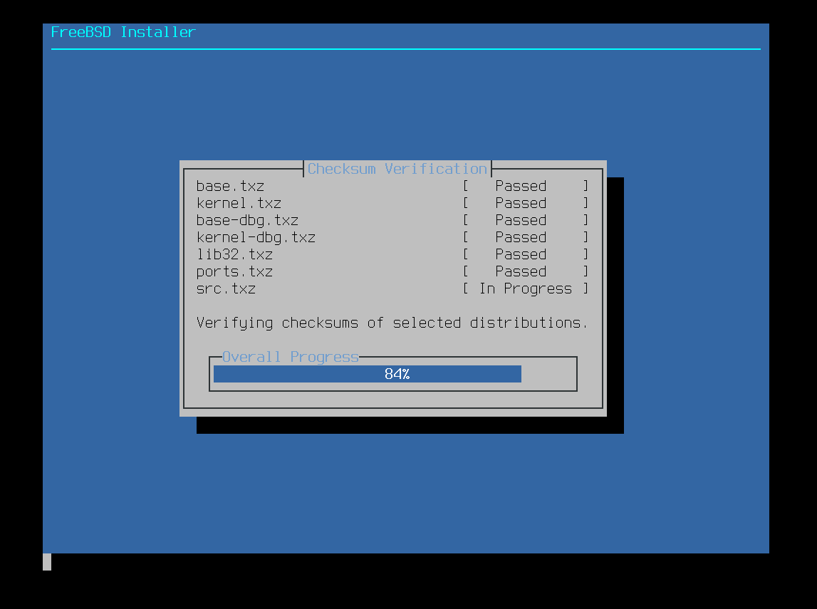

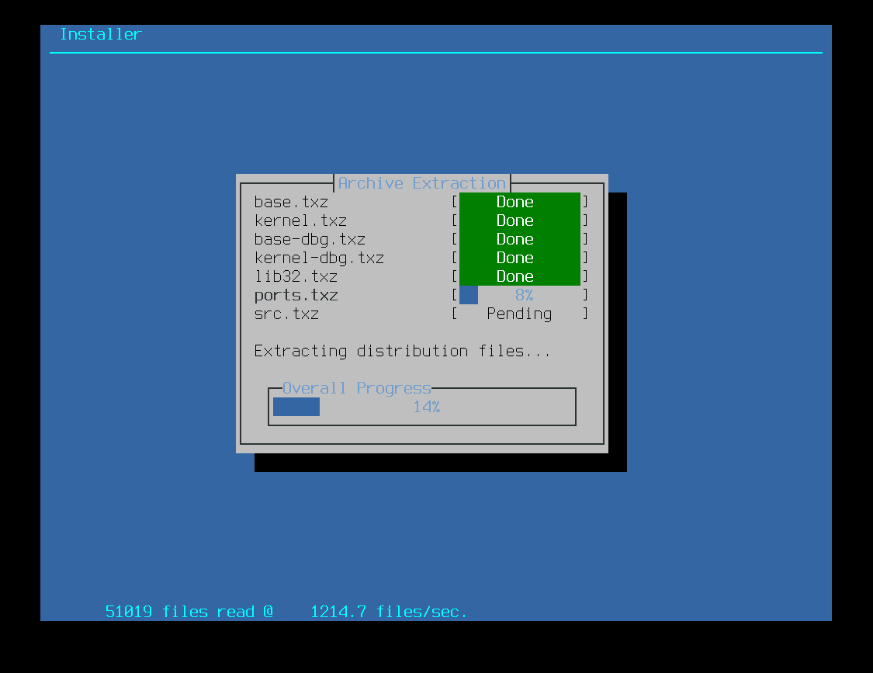

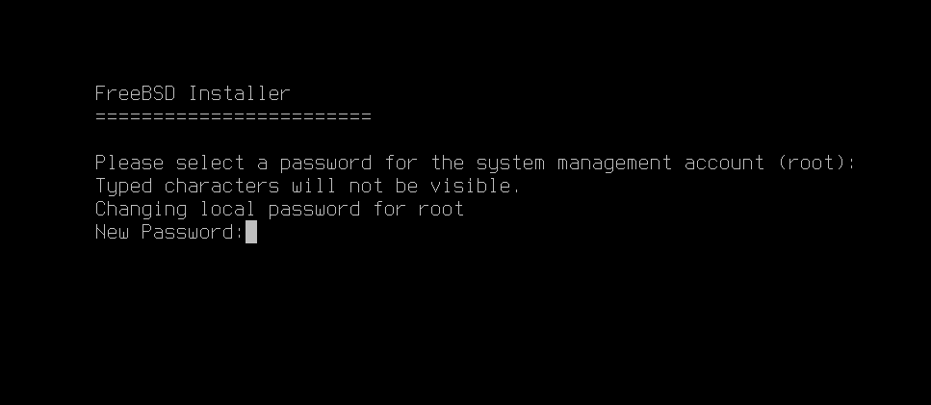

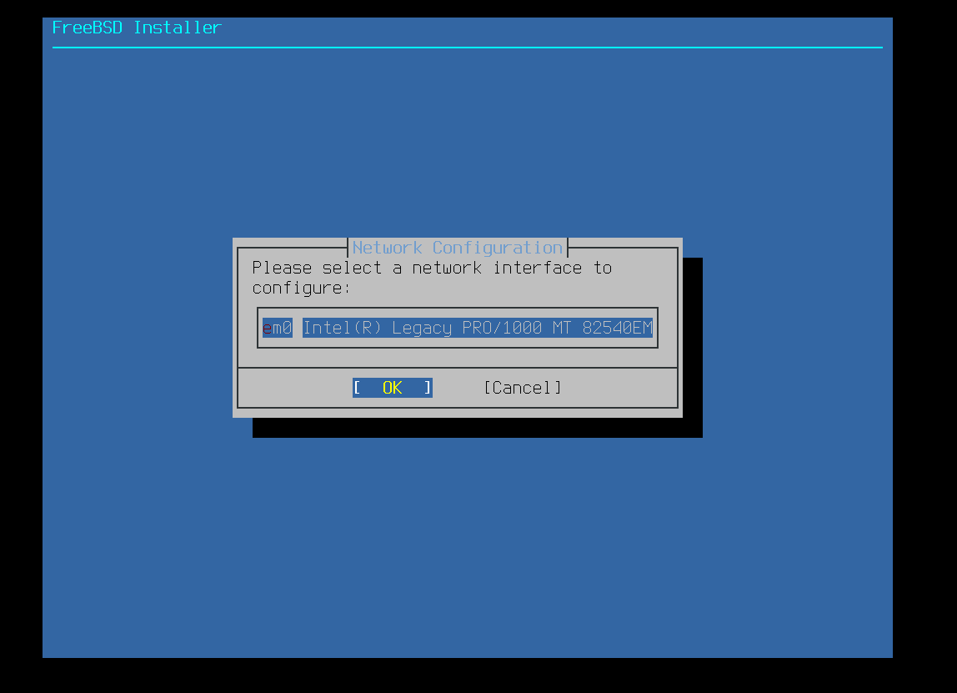

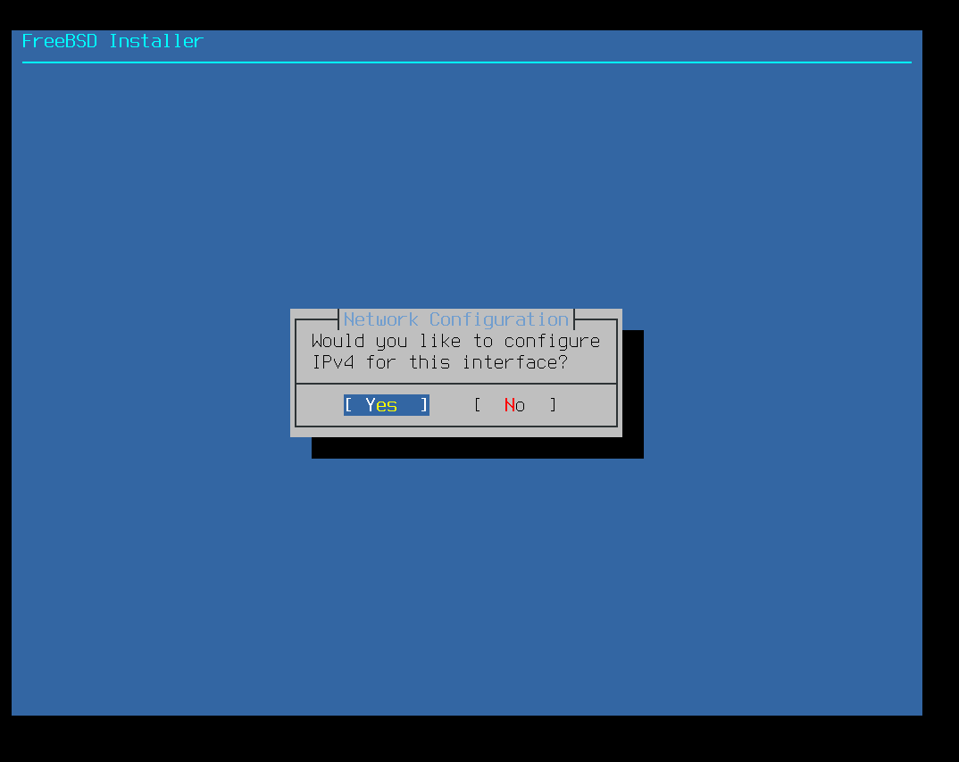

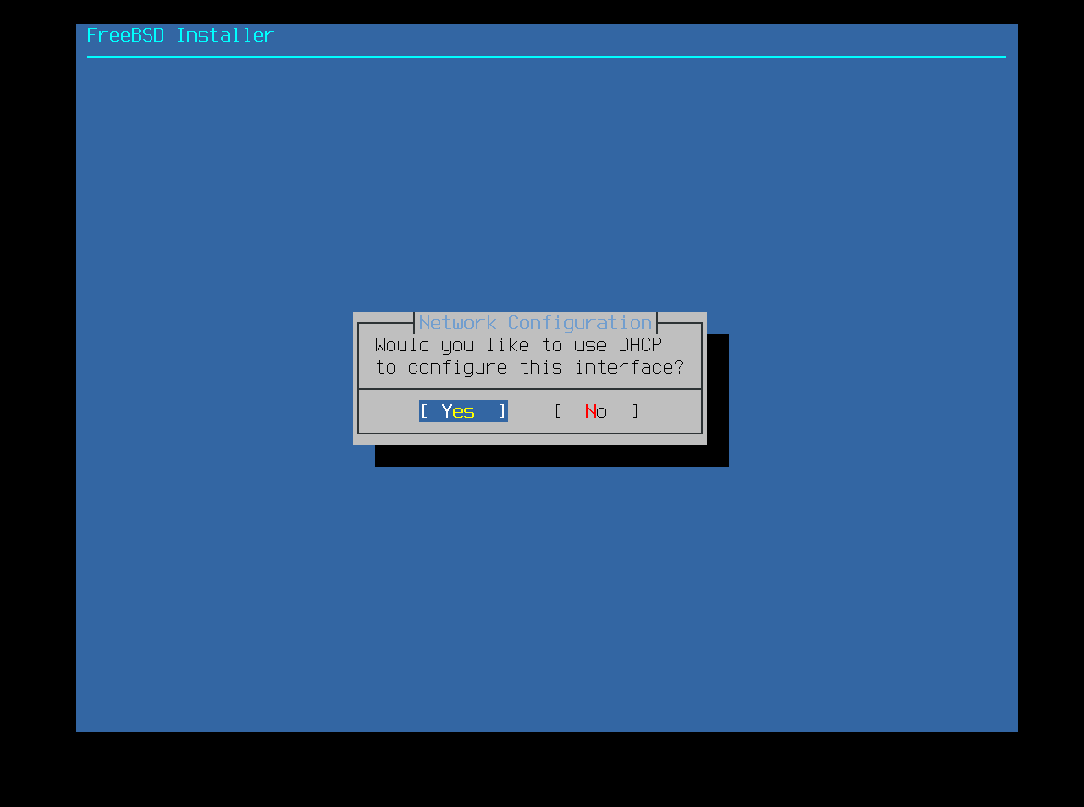

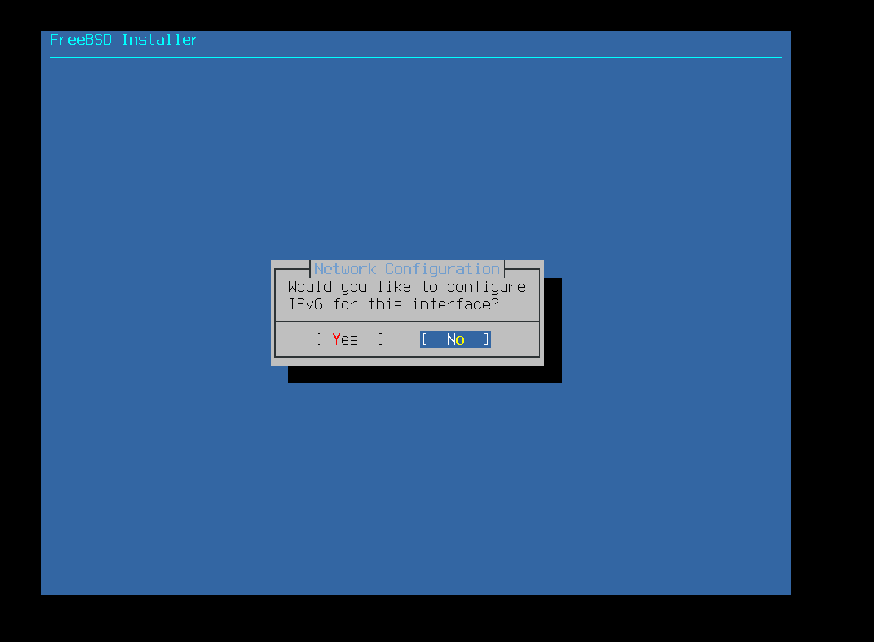

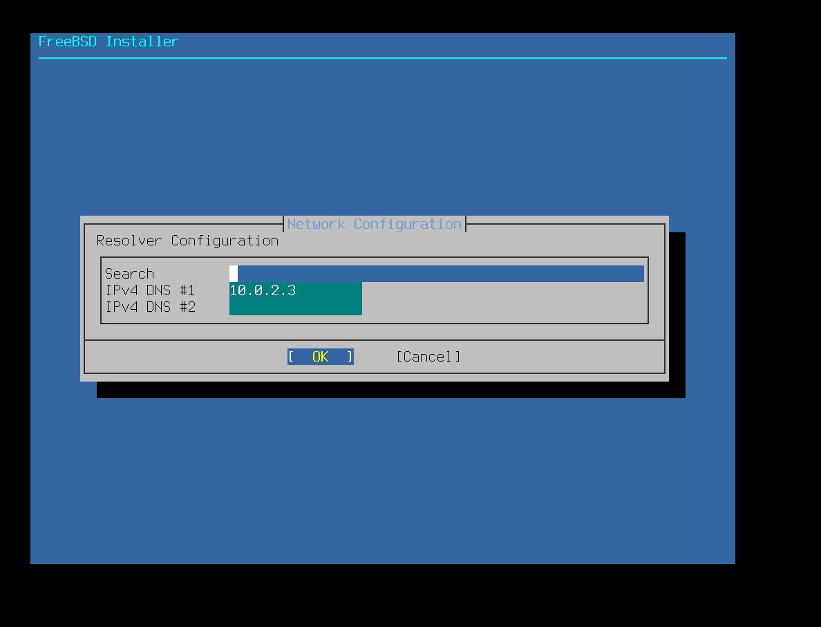

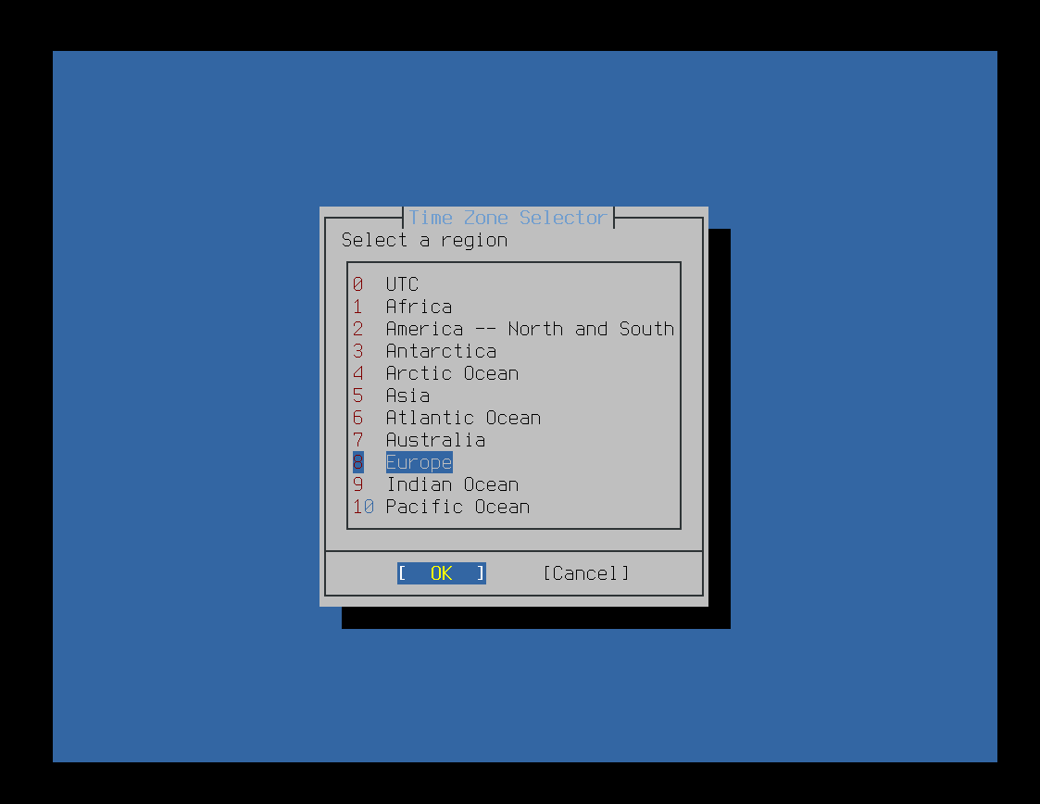

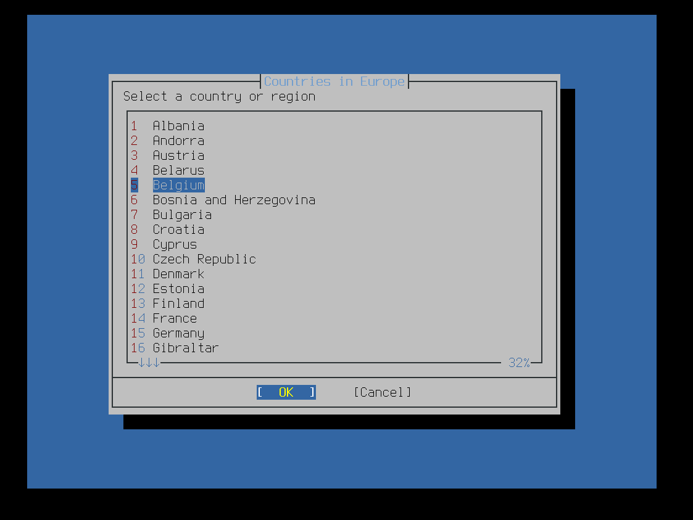

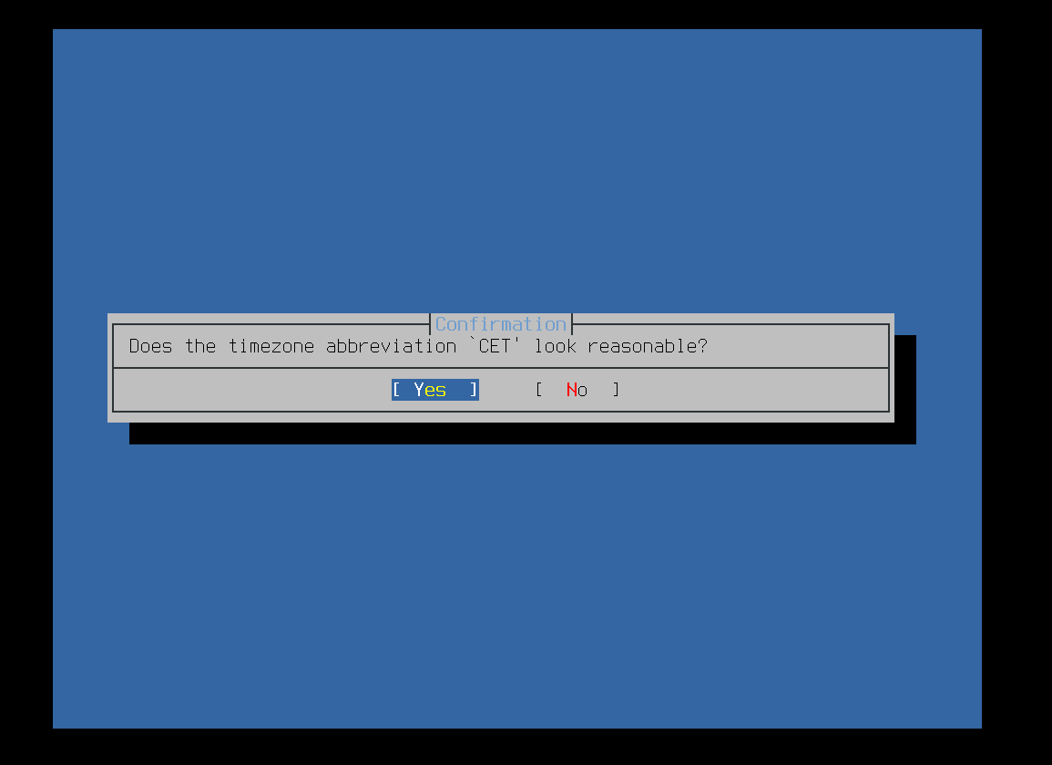

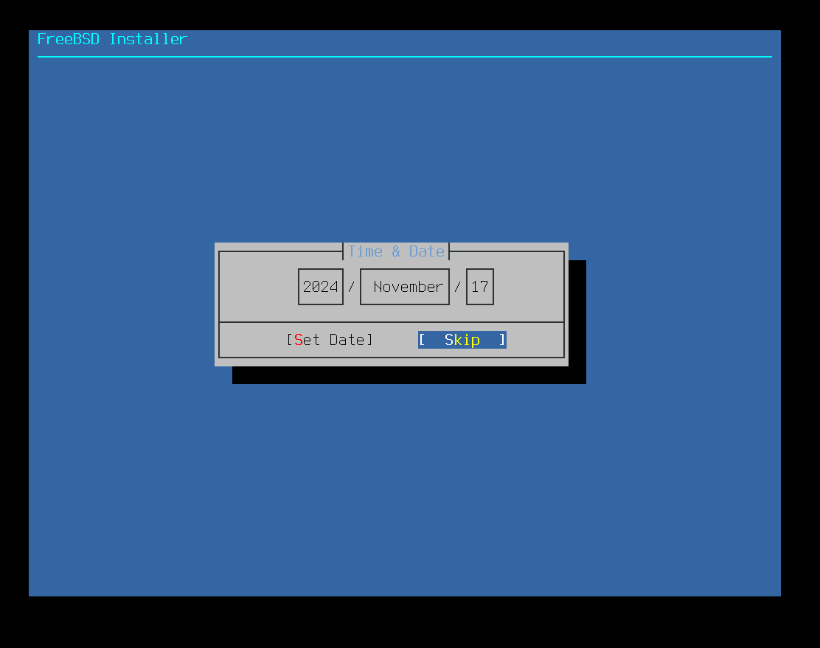

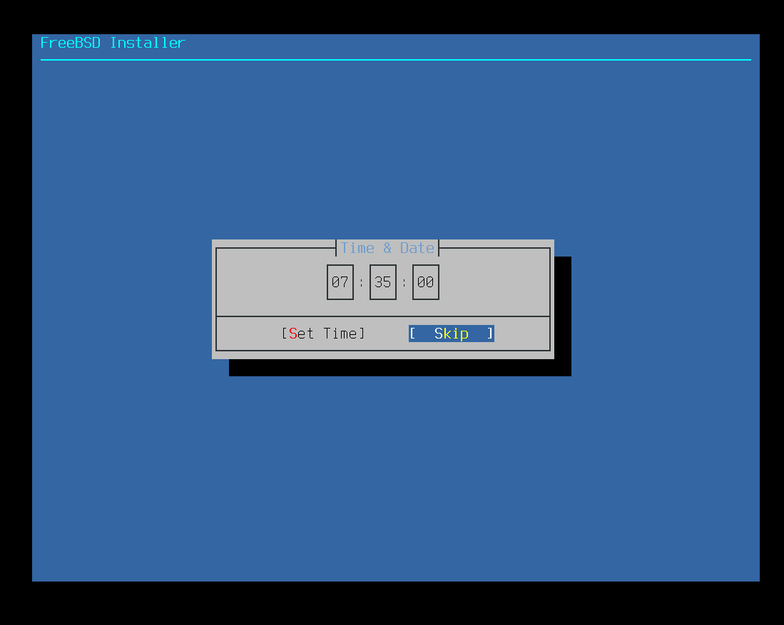

nothing here

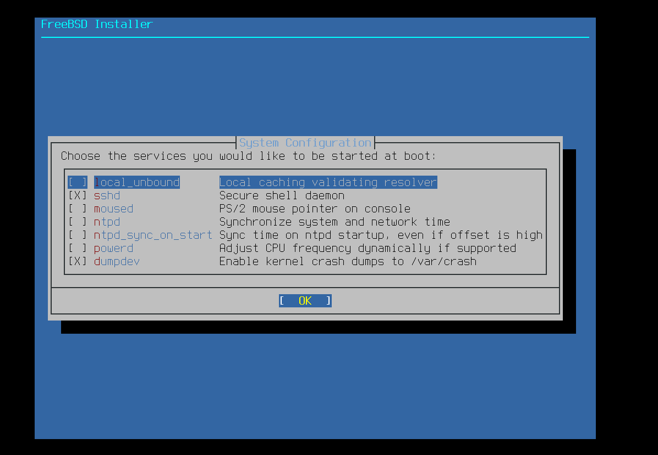

nothing here

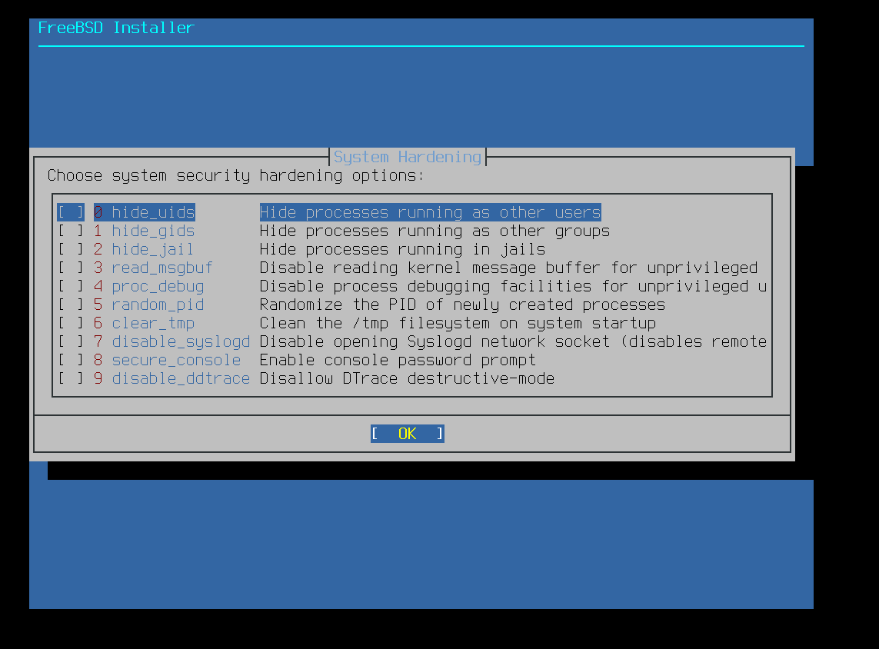

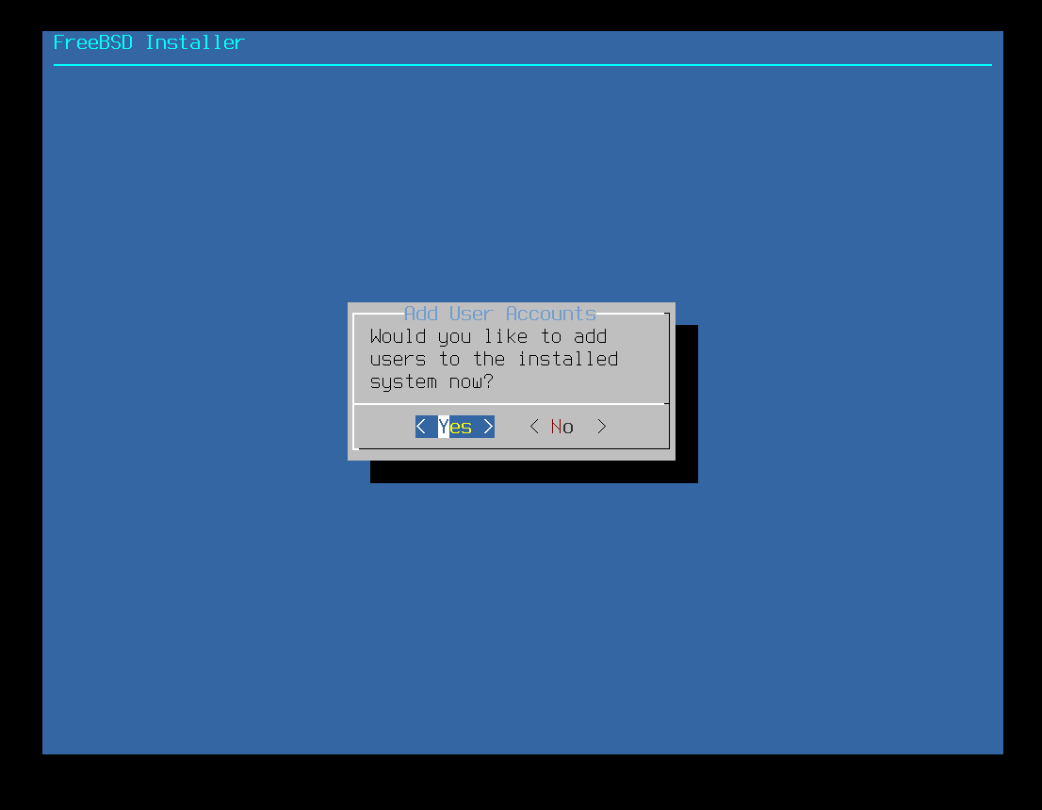

Tricky bit - no mistakes allowed

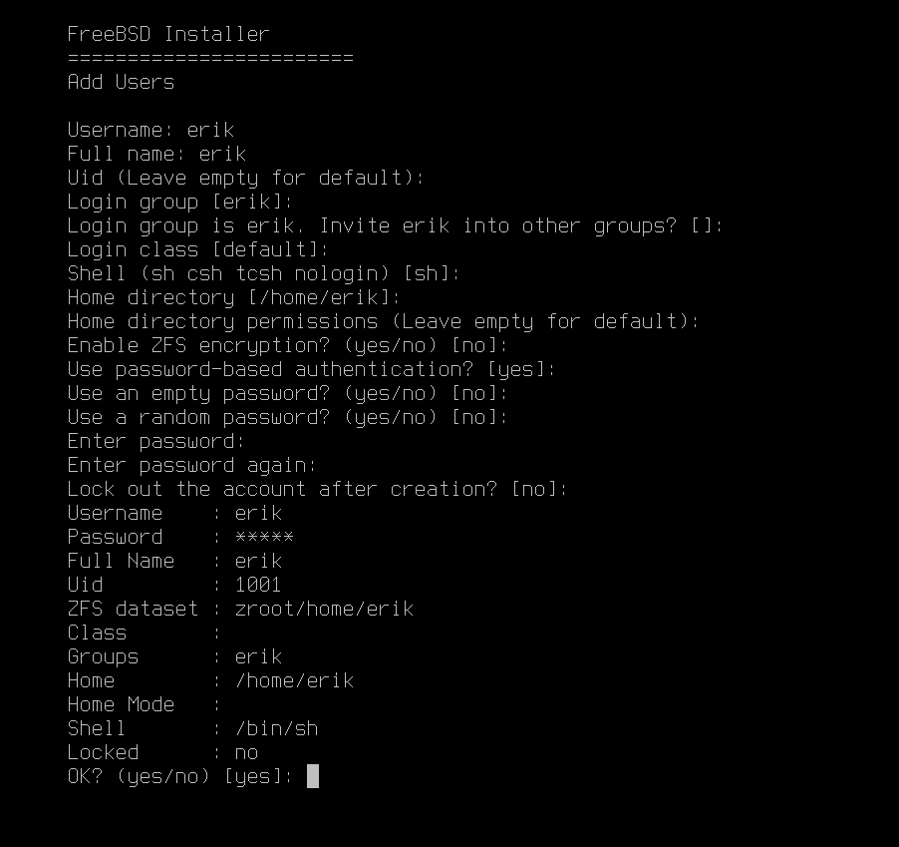

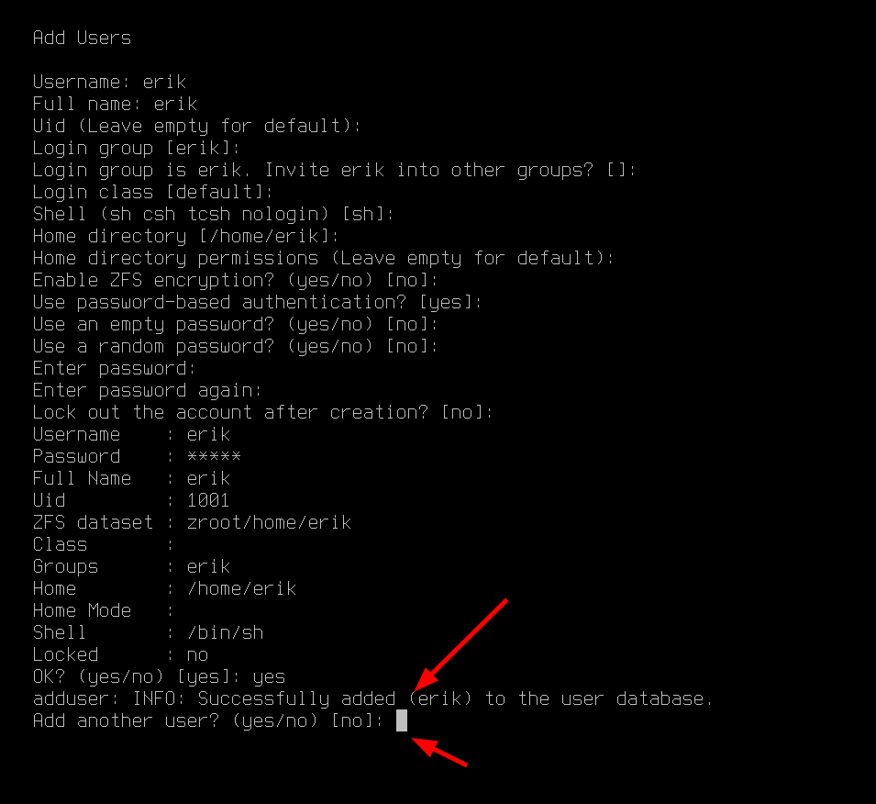

maybe adding the user to the groups

wheel

video

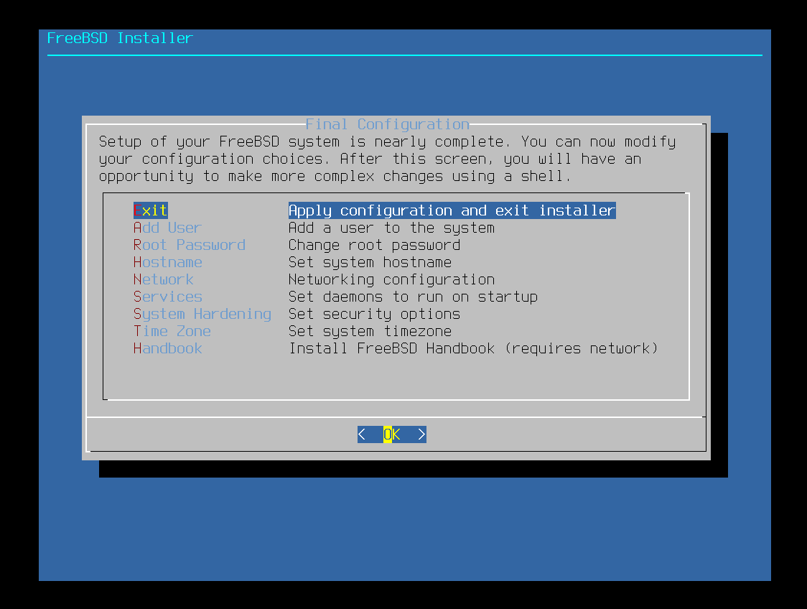

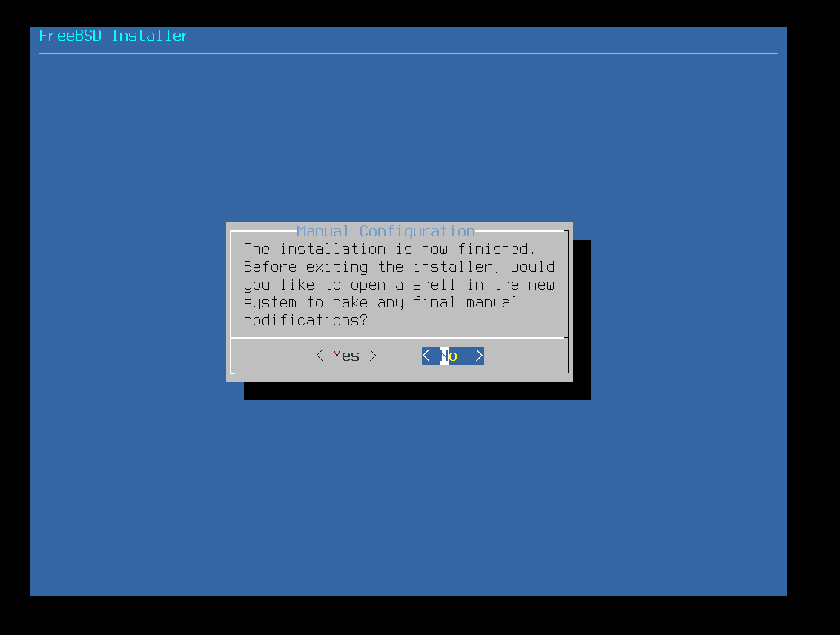

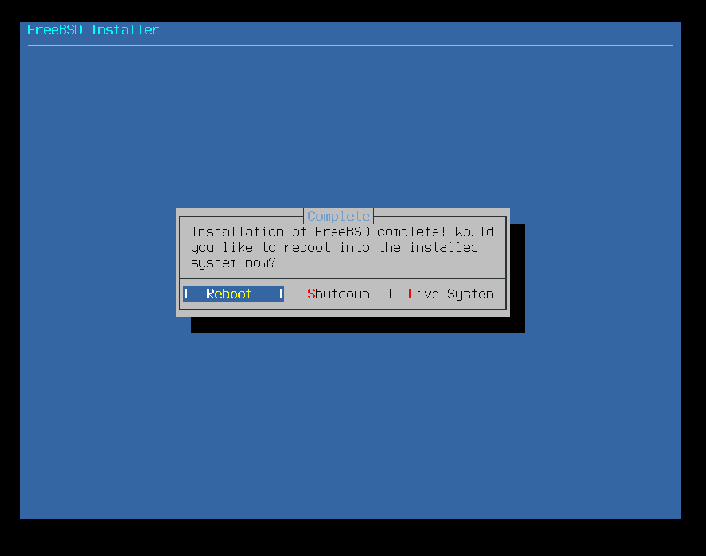

# USB finished - rebooted

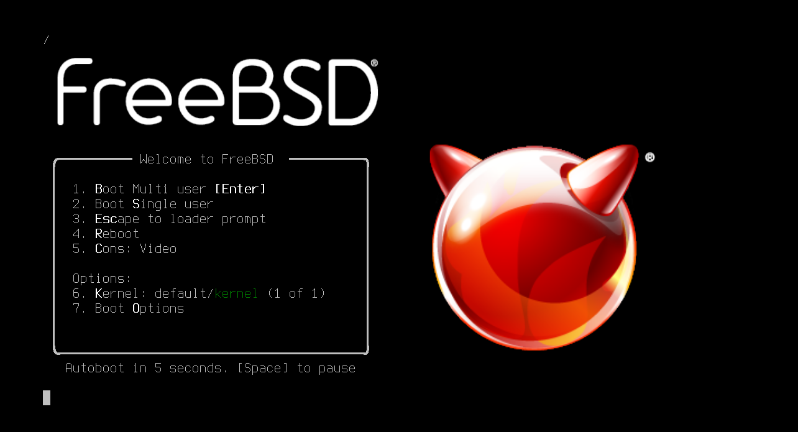

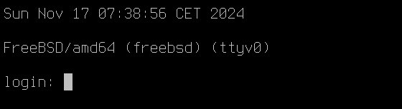

login with root and your password

*pkg update*

*pkg upgrade*

normally - nothing to update

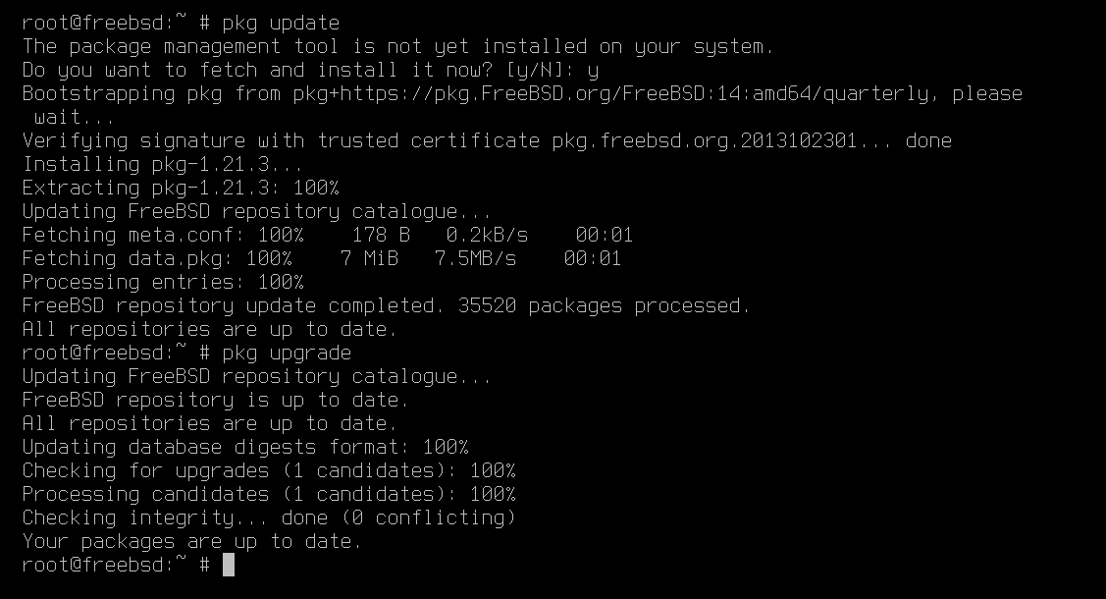

# XORG DRIVERS

<https://docs.freebsd.org/en/books/handbook/x11/>

We need xorg and drivers.

Intel and Amd use the same package *drm-kmod*

*pkg install drm-kmod*

*sysrc kld_list=i915kms*

*pkg install libva-intel-driver mesa-libs mesa-dri*

BUT here we will install it on VirtualBox

*pkg install xorg*

*pw groupmod video -m erik*

*pw groupmod video -m root*

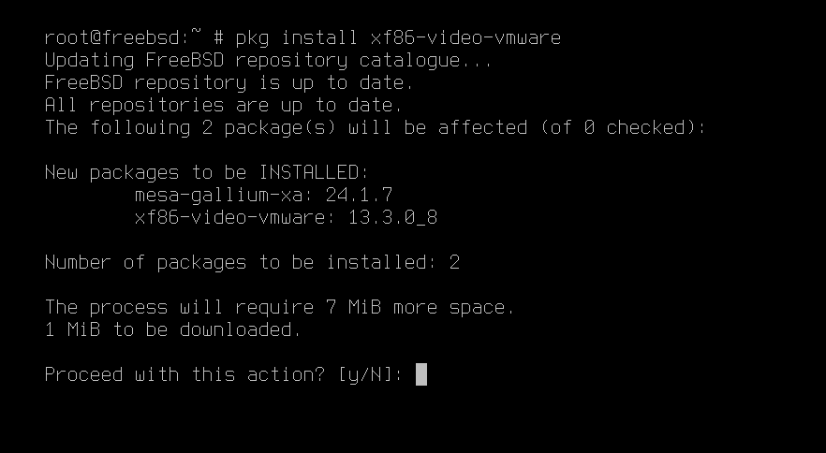

<https://docs.freebsd.org/en/books/handbook/virtualization/#virtualization-guest-virtualbox>

*pkg install emulators/virtualbox-ose-addtions*

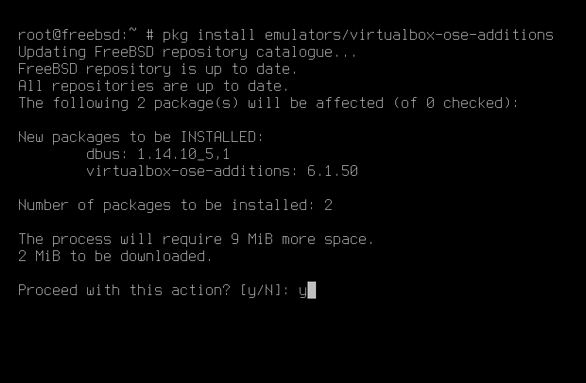

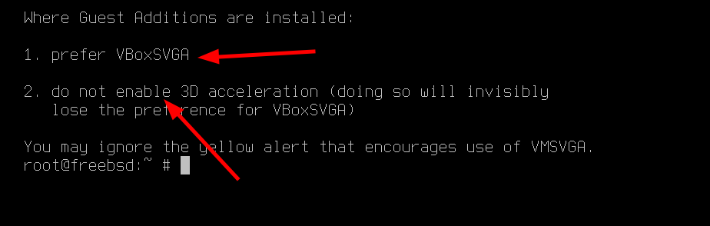

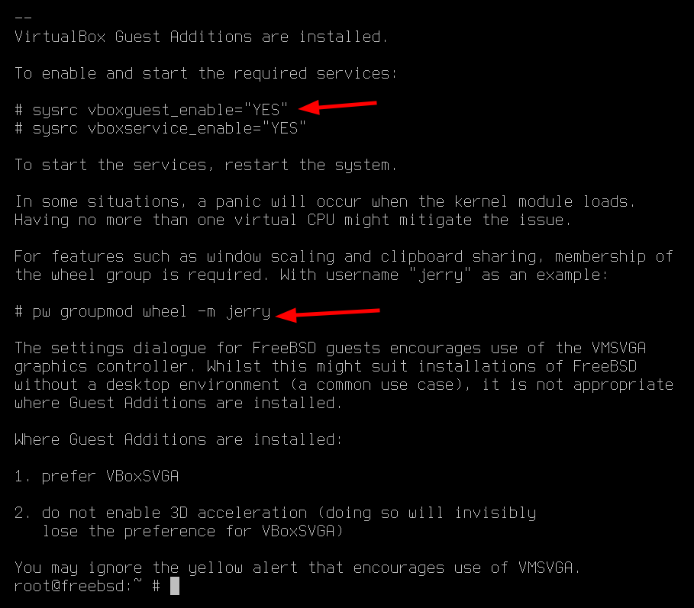

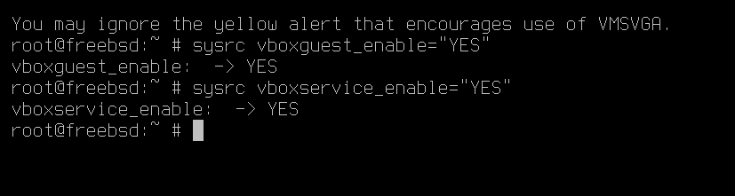

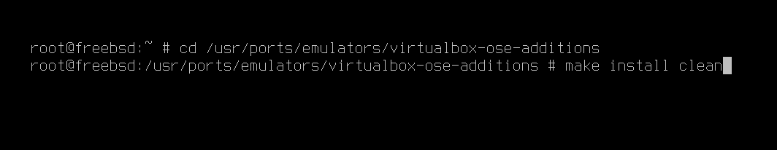

# USER PRIVILEGES

*pw groupmod wheel -m erik*

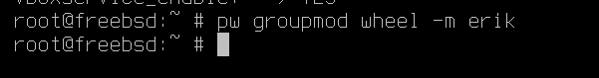

# Xfce

<https://docs.freebsd.org/en/books/handbook/desktop/>

*pkg install xfce*

*fstab edit*

*sysrc dbus_enable=”YES”*

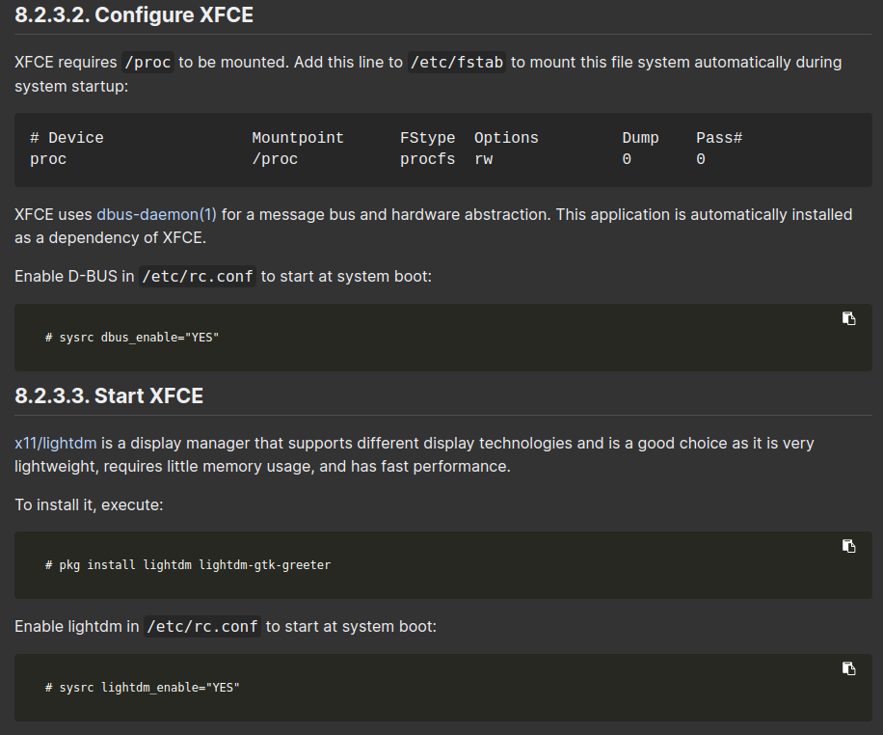

Use easy editor or ee - you can install nano - pkg install nano

*ee /etc/fstab*

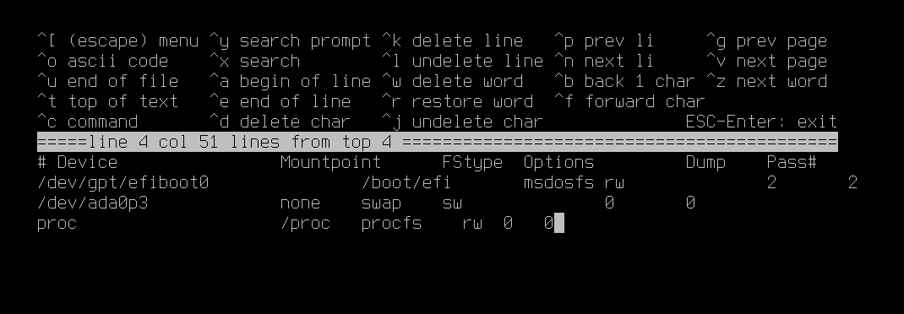

Press escape

Choose A - leave editor and save with A

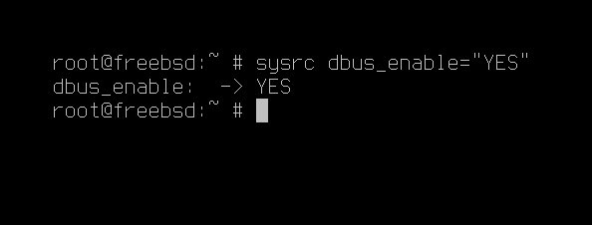

*pkg install sddm*

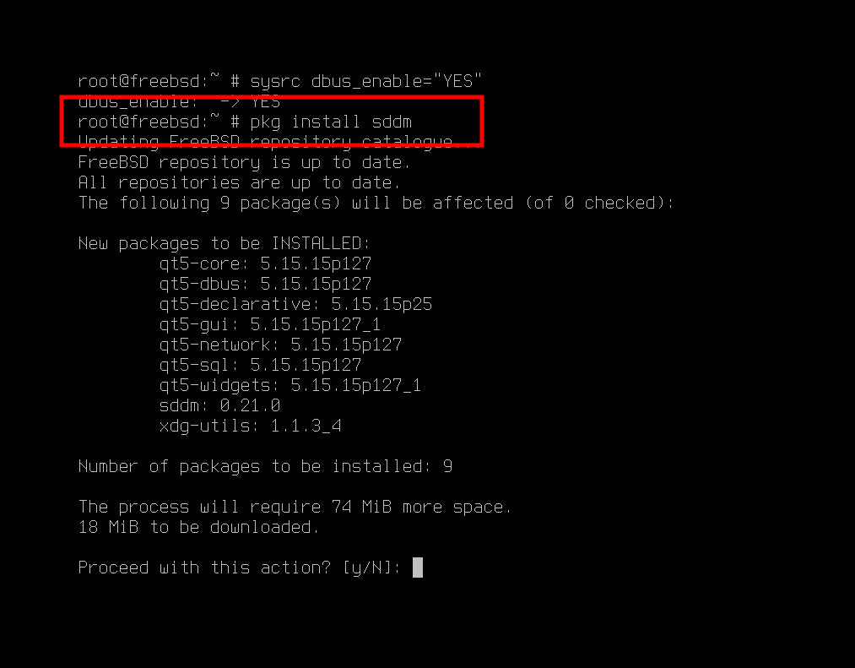

sysrc sddm_enable=”YES”

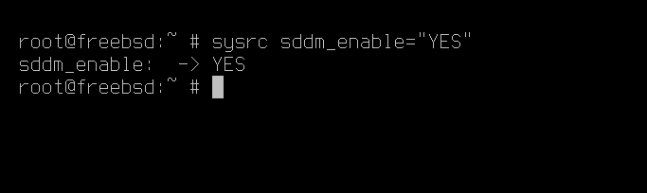

*pkg install sudo*

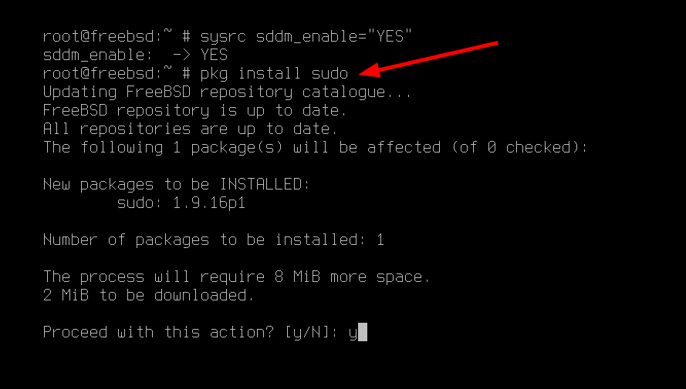

add user to visudo to gain privileges

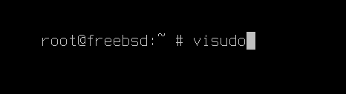

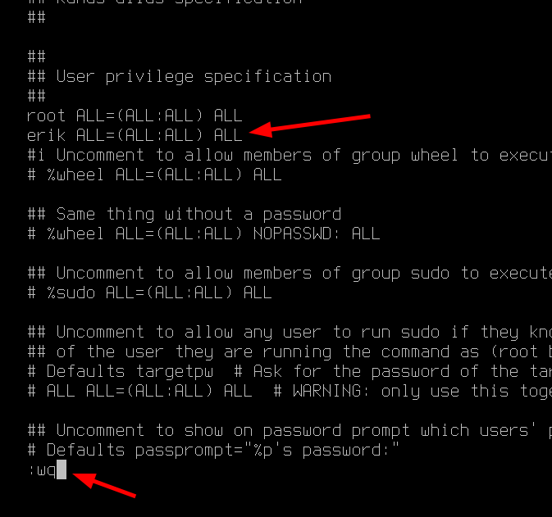

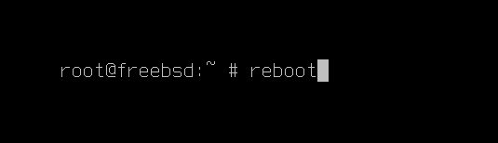

# XFCE installed - SDDM working

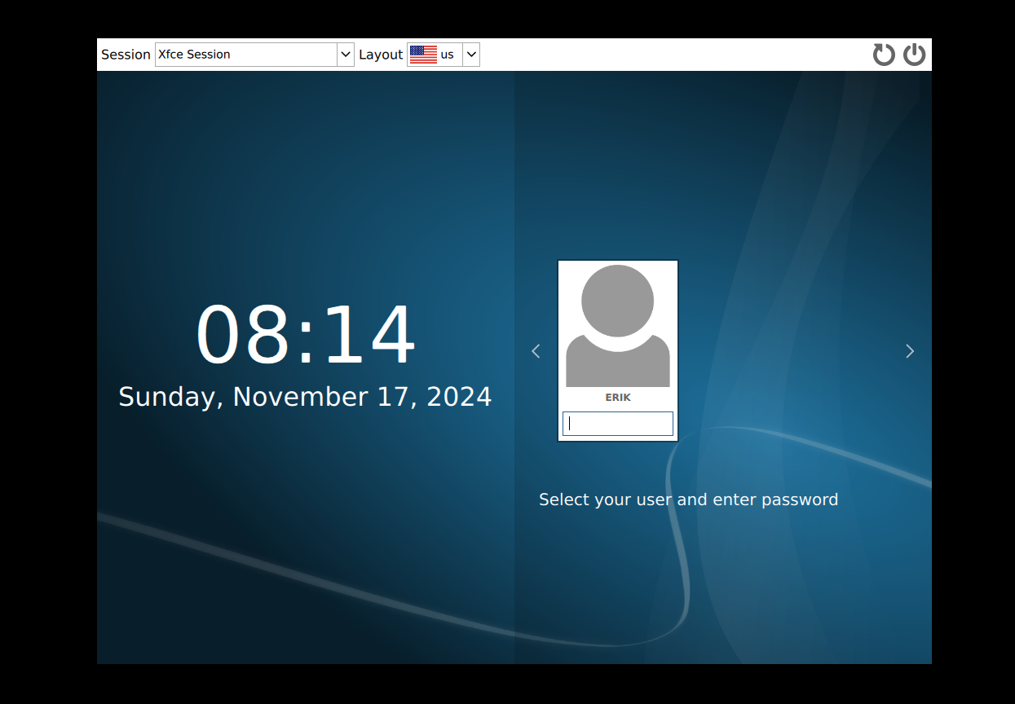

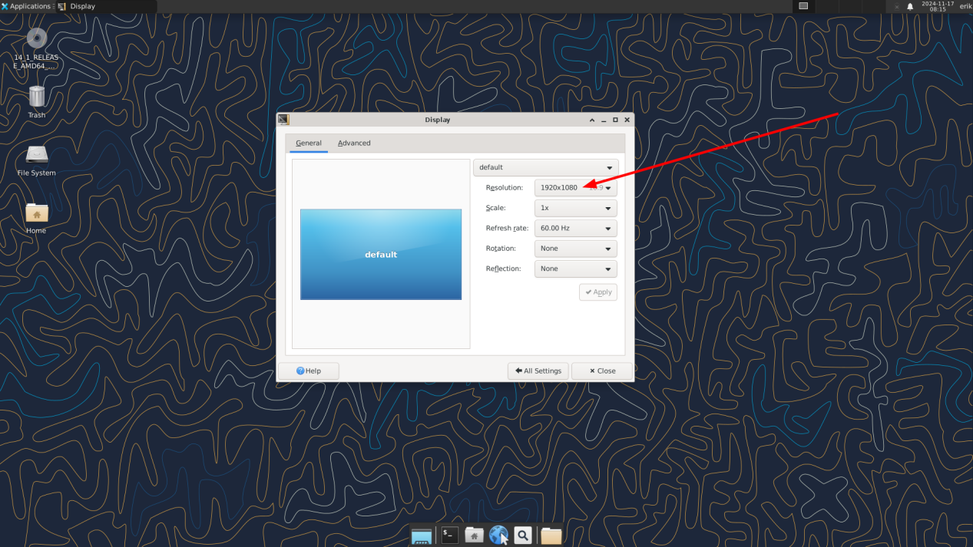

# AFTER INSTALLATION

## Packages to install

*sudo pkg install fastfetch*

*sudo pkg install fish*

*sudo pkg install git*

*sudo pkg install bash*

*sudo pkg install bash-completion*

git clone https://github.com/erikdubois/arcolinux-nemesis

Type this so the shell is in the expected place

*sudo ln -s /usr/local/bin/bash /bin/bash*

*Now you can launch the arcolinux-nemesis scripts*

*./0 press tab tab*

Default shell is fish

<https://docs.freebsd.org/en/books/handbook/basics/#shells>

*sudo chsh -s /usr/local/bin/fish*

reboot

# Issues

## USB ISSUE

In virtualbox the machine would not stop

